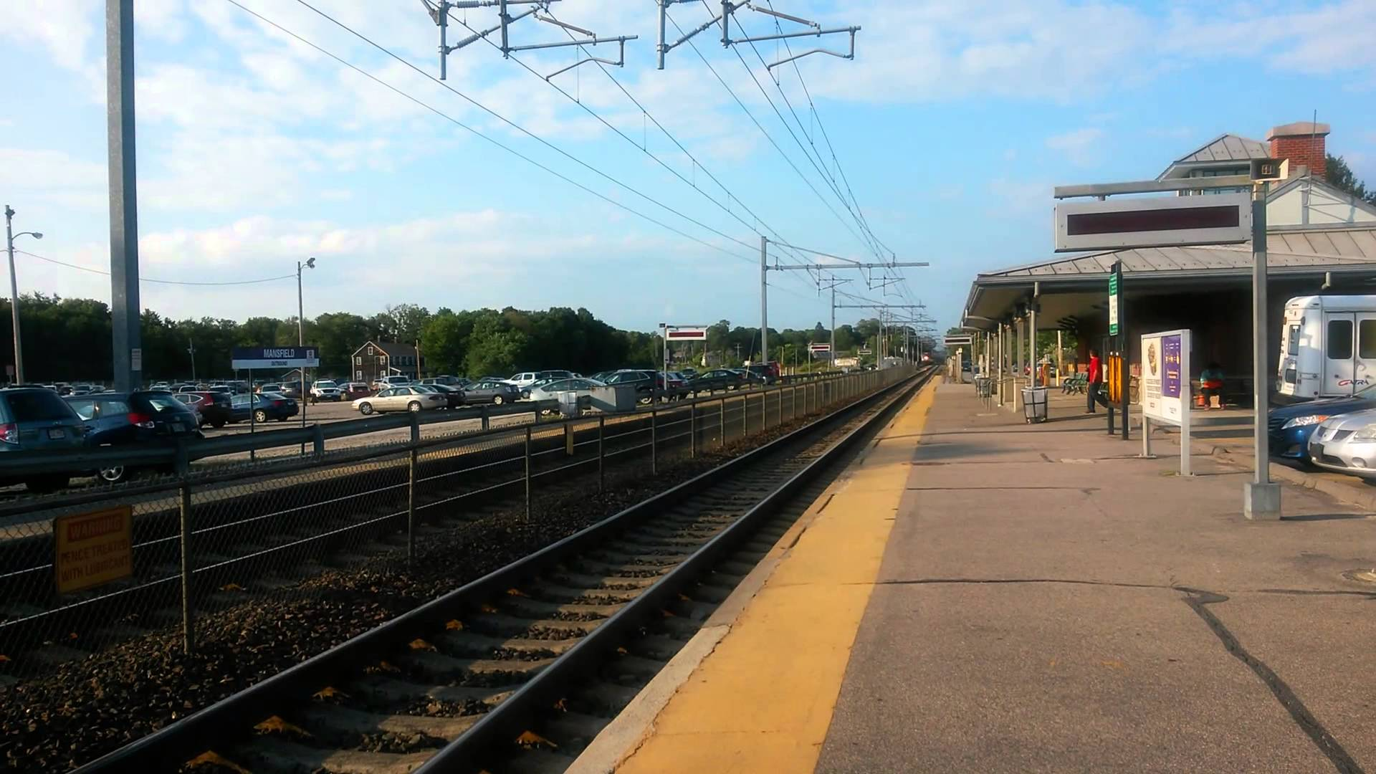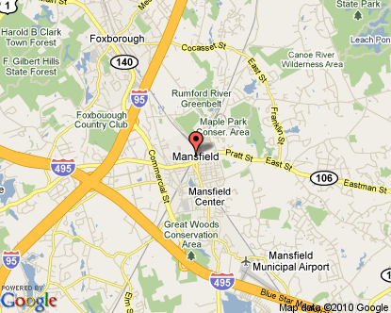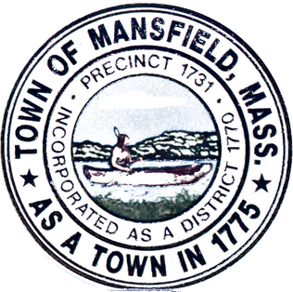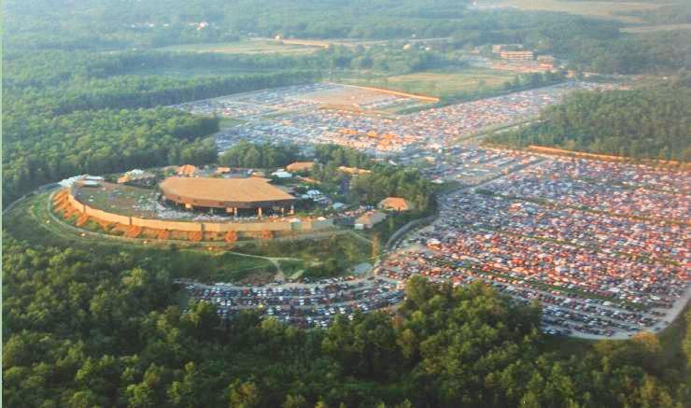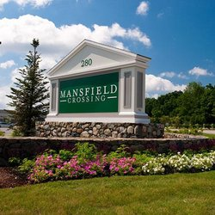

*“Where Your*

*Business Belongs”*

MANSFIELD COMMUTER RAIL

* Mansfield MBTA Providence-Stoughton Line
* Airport: Mansfield Municipal Airport
* GATRA: Bus service for local region

Mansfield is situated at the crossroads of several major highways- I-95, I-495, Route 106, and Route 140—and is a short 40 minute drive (or 25 minute MBTA ride) to Boston. The town of Mansfield is also close to the city of Providence, which can be reached by public transportation or driven to in less than 30 minutes

* Long-term master plan and short-term strategic plan prioritizing industrial and commercial developments
* Pragmatic town management allows for ease of permitting business owners
* Consistently approving TIF agreements for new investments
* Competitive tax rates provide business owners with superior municipal services
* Active tri-town Chamber of Commerce provides business-friendly advantages.
* The strategically placed Holiday Inn and Marriott are available for holding functions and seminars that are key to a successful work environment
* Mansfield is the home of the 3rd largest corporate Park in MA
* Mansfield created re-development opportunities through up-zoning in the Cabot Business Park and Downtown in the Transit Oriented Development Zone
* Ideal location to recruit highly educated workforce

*oUTER Hub of boston*

Location

* *390 West St, Mansfield MA is now renting a large commercial building.*
* *Off of Route 140 and ½ mile from 495 and Mansfield Crossing don’t miss an opportunity to expand your business here!*
* *242 Chauncy St, Mansfield MA is a smaller and more local settled commercial space for you smaller businesses. It’s down the street from the Commuter rail and is located on 106!*
* 1

Business Minded

*6 Park Row, Mansfield Ma 02048*

*Phone: (508) 261-7466*

*Fax: (508) 261-7498*

Town of Mansfield

Est. 1775

* Employees have access to affordable housing in family friendly neighborhoods with a New England town feel
* Wooded developments with large lots
* Consistently meets the state’s affordable housing goals and is committed to permitting an attractive mix of housing
* Lowney Chocolate Factory, which operated on Oakland St from 1993-2011, is being reconstructed into upscale commercial and residential units
* Mansfield’s residential tax rates are low compared to similar communities

Nearby Recreation

* Patriots Place
* Gillette Stadium
* TPC Boston
* Xfinity Center
* Mansfield Crossing
* Bike Trails
* The great woods/Corporal Hardy Conservation
* Canoe River.
* Foxborough State Forest
* Mansfield WWII Veterans Memorial Trail
* Borderland Park
* Fulton Pond

Housing+Amenities

* In 2014, U.S. News and Boston magazine listed MHS as one of the top 50 schools in MA
* Nerdwallet ranked Mansfield 4th for best school for your money
* MHS offers a wide range of athletics: hockey, soccer, football, swimming, track&field, basketball, and wrestling
* MHS football ranked No. 1 in 2013 in state and has won 7 state championships
* Nearby private schools: Foxborough Charter School, the Sage School, Al-Noor Academy, Hands-on Montessori School, Perduco Education, New Testaments, and St Mary’s Catholic School.

Population

1990 2010

Mansfield 16,568 23,184

Norton 14,265 19,031

Foxboro 14,637 16,865

Median Resident Age: 38 years

Population

1990 2010

Mansfield 16,568 23,184

Norton 14,265 19,031

Foxboro 14,637 16,865

Median Resident Age: 38 years

A GREAT PLACE TO RAISE A FAMILY AND BUSINESS

Population

1990 2010

Mansfield 16,568 23,184

Norton 14,265 19,031

Foxboro 14,637 16,865

Median Resident Age: 38 years

strong work force

* Mansfield Municipal Electric has received recognition for achieving exceptional reliability from the American Public Power Association
* Modern and professional police and fire departments
* Recently completed major water system upgrade that provides reliable and surplus water for 20+ years
* Member of a wastewater treatment district that is expanding capacity at the treatment plant by one million gallons per day

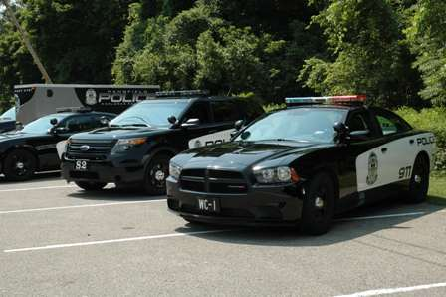

World Class INFRASTRUCTURE